Animation of symmetric operations

The program's animation draws inspiration from Symmetry@Otterbein and PGLite for illustrating animated symmetry operations. If one wishes to employ the current program for showcasing symmetry operations through animation, the following steps can be followed.

1. Open VMD, drag the molecules in the Resources folder into the VMD window. From the menu of VMD, select Extensions -> Analysis -> Symmetry Tool. Then, in the Symmetry Tool window that appears, click on the Guess-Symmetry button to display symmetry elements and point groups.

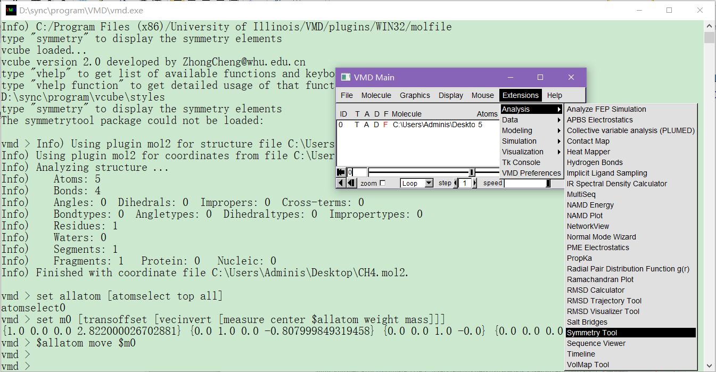

1. Within the Symmetry Tool interface, select the desired symmetrical elements, and corresponding animations will be displayed in the Display interface.

